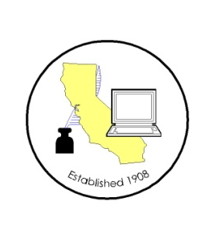
CALIFORNIA ASSOCIATION OF

CLERKS AND ELECTION OFFICIALS

January 6, 2012

TO: CACEO Members, Guests, Legislative Committee

FROM: Deborah Seiler and Jill LaVine, Co-Chairs

SUBJECT: CACEO LEGISLATIVE COMMITTEE MEETING

DATE: FRIDAY, January 13, 2012

TIME: 9:00 a.m. – 3:00 p.m.

LOCATION: County of Sacramento
799 G Street, OCIT – 2nd Floor Conference Room
Sacramento, CA 95814

Subcommittee Meetings, Thursday, January 12, 2012

10 am- Noon Petitions – Deborah Seiler

1 pm – 3 pm Voters with Specific Needs – Tim McNamara

3 pm – 5 pm HAVA/Certification/Voting Systems – Tim McNamara

FRIDAY AGENDA (Tentative)

9:00 am Welcome and Introductions

Presentation by Phillip Ung, Common Cause: Voter lookup

Discussion of Election Day Registration
(Member of Assembly member Mike Feuer’s staff)

Presentation of 2012 Bill Proposals
(Bring your proposals to share)

Discussion of New Bills
AB 299 Eng
AB 1413 Fong
Urgency legislation regarding Central Committees

Subcommittee Reports

Adjourn

